import pandas as pd
import numpy as np
from sklearn.model_selection import train_test_split
from sklearn.metrics import precision_score,balanced_accuracy_score
Preprocessing done using 1hot encoding.
That is y attributes are converted into 0’s or 1’s

Now training and testing data was split into 80 – 20
Here we are working on 768 datapoints with each having 8 attributes.
After that building of decision tree using training data:
Iterate through each attribute to find the best split.
store attribute values of all data points inside a list.
sort then and find the median value.
Now we can split the data WRT selected attribute based on the median
(if x<50 then data point goes left otherwise right)
calculate entropies of root, left child and right child.
Now calculate Information gain = ent(root) – weighted_ent(both childs)
The attribute with maximum information gain is selected as a root node and split the data.
Now call buildtree function recursively for left subtree and right subtree.
Breaking condition is when all labels are unique or no label exists

Now test the decision tree model for each data point.
take a data point and starting from the root node, traverse through the tree until reaching leaf node.
If prediction is true then it increases the accuracy.
Like this I achieved an accuracy of 70
Generally as decision tree grows very deep, generally overfitting occurs.
i.e model is learning too much from training data instead of identifying underlying patterns.

So I apply pruning. (post pruning)
Pruning:
We will replace the subtree with label value with max frequency.
Lets say we have 15 1’s and 10 0’s I replace the subtree with 1.
Like this I applied pruning at each depth and plotted the graph.
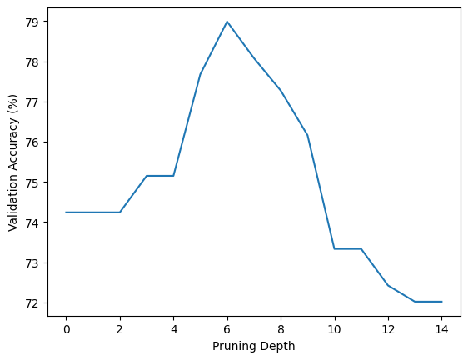
Accuracy is increasing upto depth d and then decreasing
at d=0, accuracy=70 (overfitting)
at d=do, accuracy=79
at d=maxheight, accuracy tends to 0. (underfitting)

k fold cross validation:
split the data into 5 parts
lets say A,B,C,D,E
case 1:
testing = A
training = B+C+D+E
case 2:
testing = B
training = A+C+D+E
.
.
.
.
case 5:
testing = E
training = A+B+C+D
final accuracy = mean of all 5 accuracies

